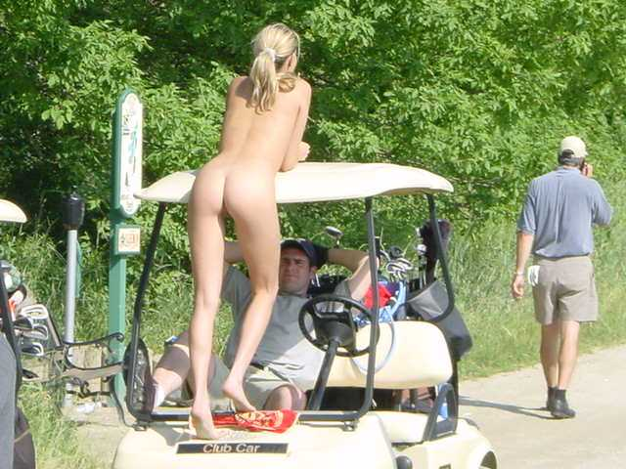

IN CONJUNCTION WITH THE SKI & BOAT RACERS REUNION WEEKEND HOW ABOUT JOINING US IN A GOLF GAME AT

FORSTER TUNCURRY GOLF CLUB
STRAND ST FORSTER

FRIDAY 9TH JULY 2010 AFTERNOON
9 HOLE AMBROSE
TEE TIMES FROM 11.00 AM

CONTACT=
KEN (TILLO) TILLING 02 6680 2995
RON (POGO) CALLAGHAN 02 6583 5510
Cart Bookings call
PRO SHOP 02 6554 6167

